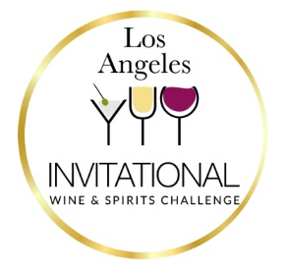

Welcome to the 4th Annual Los Angeles Invitational Wine & Spirits Challenge!

**Early Bird Discount $20 per Entry –** Ends February 3rd, 2025

**Entry Deadline** - February 13th, 2025

# About

# *The Los Angeles Invitational Wine & Spirits Challenge was established, in conjunction with LA beverage professionals, to highlight the best of the best wine & spirits producers in the world. Our panel of esteemed judges include winemakers, distillers, sommeliers, beverage trade and media.*

# *The mission is to introduce those elite producers to the Southern California market of consumers, one of the largest in the country.*

**Entry Deadline:** February 13th, 2025

**Competition Judging:** February 25th-26th, 2025

**Early Bird Entrant Fee**: The registration fee is $325 per entry / $175 Mixers and Pre-Mixed Cocktails. (Save $20 per entry)

**Entry Fee: February 4th – February 13th**:The registration fee is $345 per online entry / $195 Mixers and Pre-Mixed Cocktails.

*All spirits must arrive at Express Wine Delivery no later than February 14th at 5 p.m.*

*Express Wine Delivery, 7970 Cameron Dr., Windsor, CA. 95492, Attn: LA Invitational Spirits Comp.*

*Download shipping labels* [*here*](https://1drv.ms/b/s!AkwK9DIywyPqhY0SwZ2L-ELrV7kK0Q?e=q4cvbP)*.*

***How many bottles need to be sent per entry?***

*An official entry shall consist of two bottles per entry for 750 ml and larger.*

*For sizes less than 750 ml, (350ml) please submit three bottles per entry.*

*If packaged in cans, please send 8 per entry.*

Please contact us at 414-640-6337 or [contact@lainvitational.com](mailto:contact@lainvitational.com) [lainvitational.com/los-angeles-invitational-spirits-challenge](https://lainvitational.com/los-angeles-invitational-spirits-challenge/)